Pondhu Primary School
Penwinnick Road, St Austell, Cornwall. PL25 5DS
Headteacher: Debbie Tregellas B.Ed.
Deputy Headteacher: Sarah Parekh B.Ed.
T: 01726 74550 www.pondhu.eschools.co.uk

7th January 2021

Dear Parents and Carers,

The Government are running a pilot scheme to support increasing children and young people’s access to increased mobile data allowances. This is to support their home learning whilst not able to access schools.

This scheme is open to children and young people who:

• Don’t have access to a fixed broadband connection

• Cannot afford the additional data needed to access educational resources or social care services

• Have access to a mobile device that uses a participating network

•Are facing disruption to their face-to-face education, or have been advised not to attend school

Information that will be needed in order for us to request additional mobile data includes:

• The account holder’s name

• Their mobile number (a number beginning with ‘07’)

• Their mobile network

•Whether they pay monthly or pay as they go
It is also requested that you read through the Privacy Policy (https://get-help-with-tech.education.gov.uk/increasing-mobile-data/privacy-notice) before making any form of decision.

If this is something you feel you are entitled to access, please use the Data link or QR code below to enter some information to support your request. Please ensure this is completed no later than
12 noon on Monday 11th January, to enable us to upload the information to the DfE. We would be thrilled if lots of our families managed to get this support, however, there is no guarantee that our request will be successful.
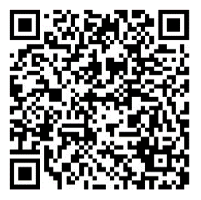
Yours faithfully, Data

Mrs D Tregellas
HEADTEACHER

