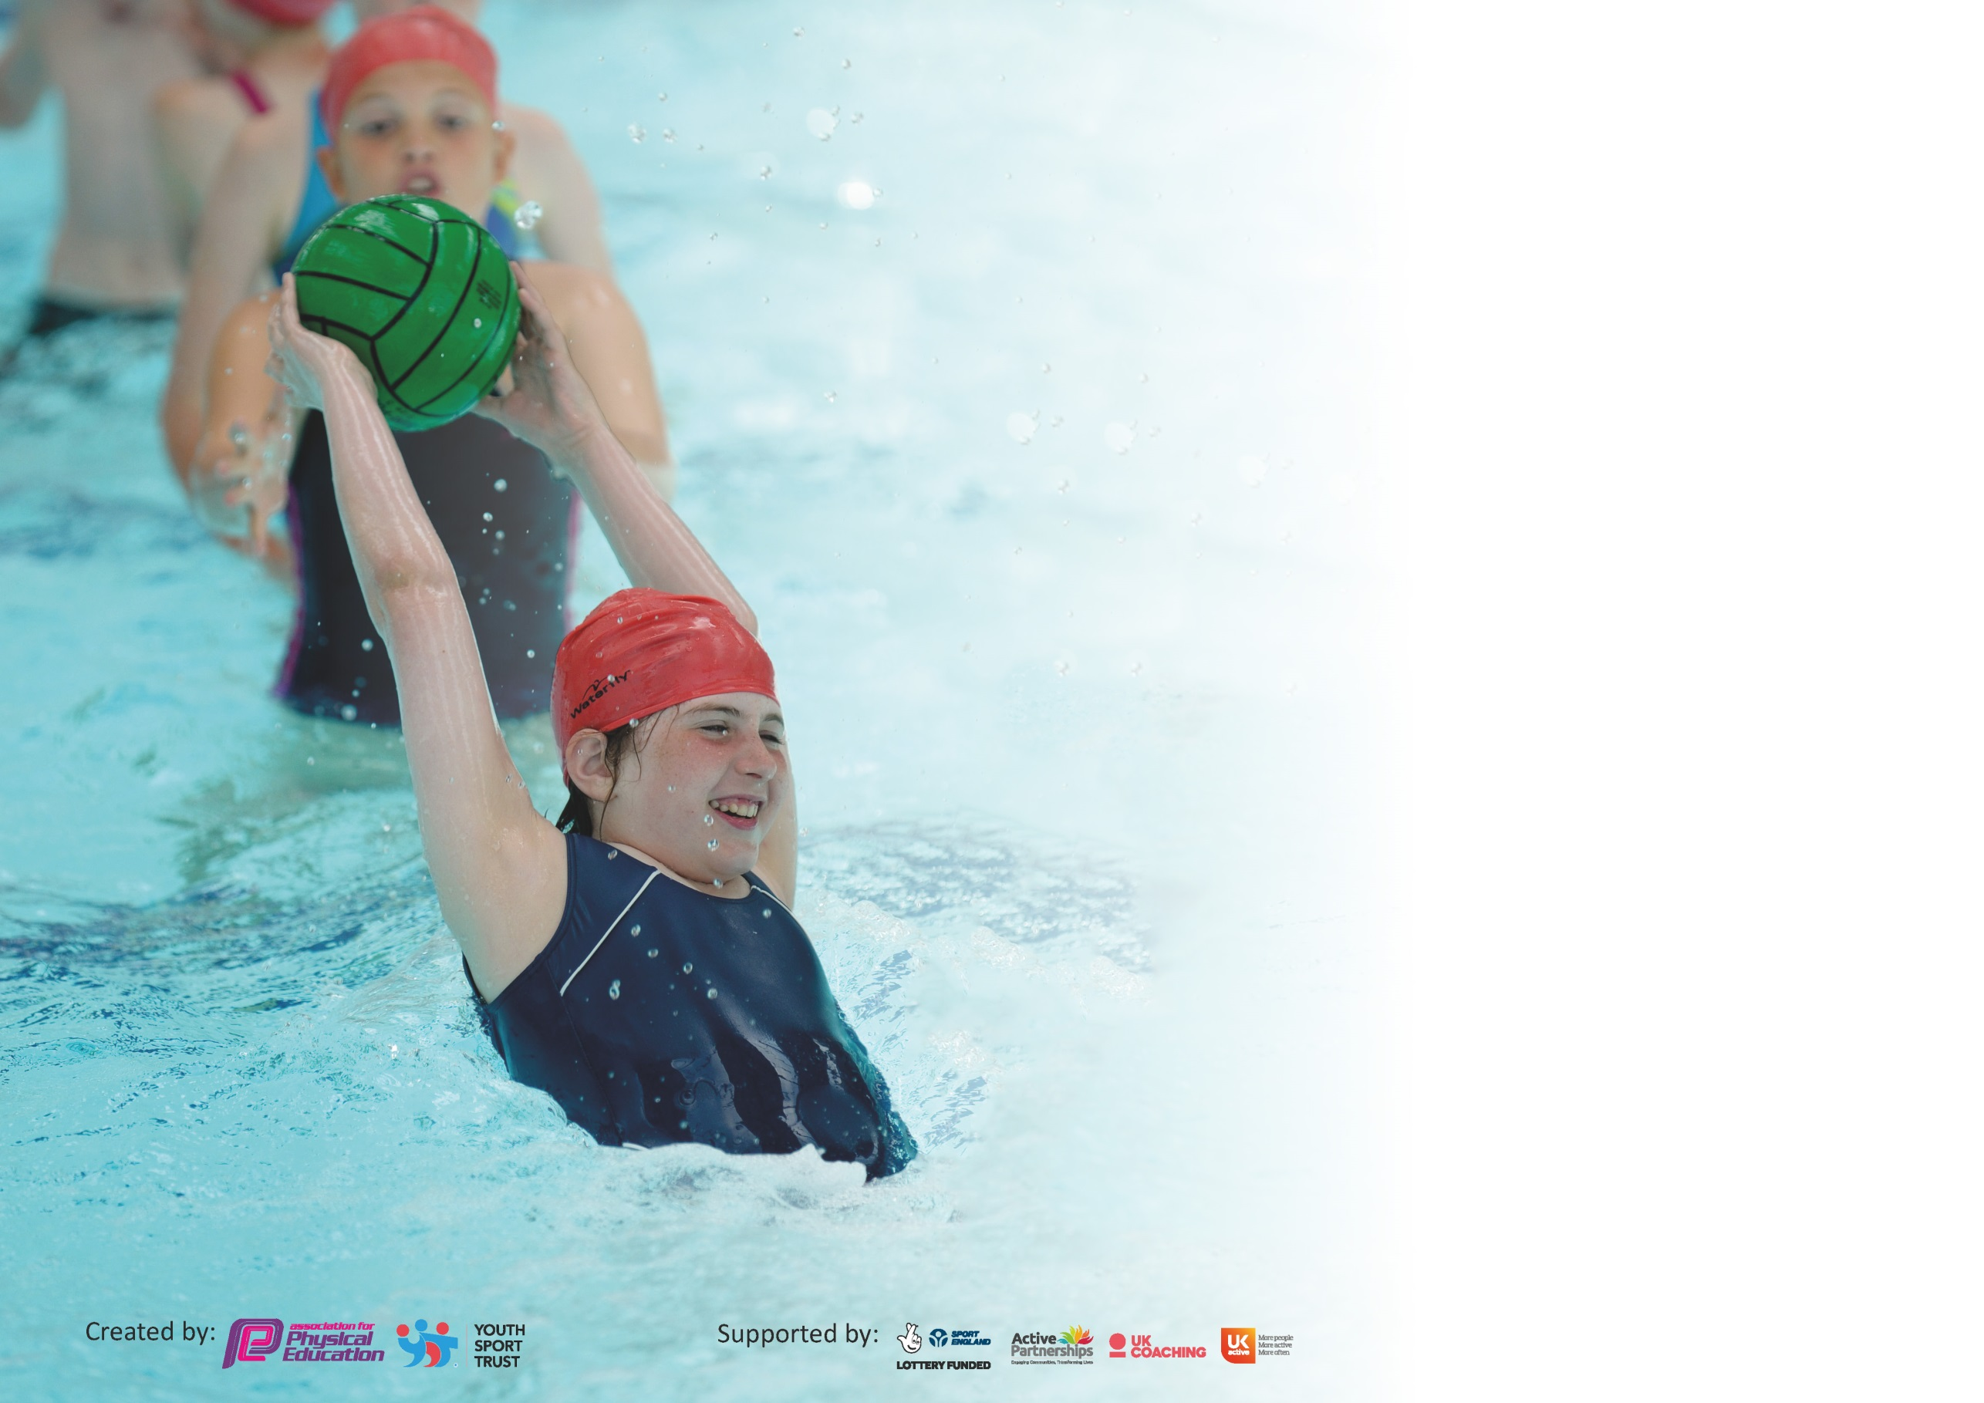

It is important that your grant is used effectively and based on school need. The Education Inspection Framework (Ofsted 2019 p64) makes clear there will be a focus on ‘whether leaders and those responsible for governors all understand their respective roles and perform these in a way that enhances the effectiveness of the school’.

Under the Quality of Education criteria (p41) inspectors consider the extent to which schools can articulate their curriculum (INTENT), construct their curriculum (IMPLEMENTATION) and demonstrate the outcomes which result (IMPACT).

To assist schools with common transferable language this template has been developed to utilise the same three headings which should make your plans easily transferable between working documents.

Schools must use the funding to make additional and sustainable improvements to the quality of Physical Education, School Sport and Physical Activity (PESSPA) they offer. This means that you should
use the Primary PE and Sport Premium to:

- Develop or add to the PESSPA activities that your school already offer
- Build capacity and capability within the school to ensure that improvements made now will benefit pupils joining the school in future years

Please visit gov.uk for the revised DfE guidance including the 5 key indicators across which schools should demonstrate an improvement. This document will help you to review your provision and to report your spend. DfE encourages schools to use this template as an effective way of meeting the reporting requirements of the Primary PE and Sport Premium.

We recommend you start by reflecting on the impact of current provision and reviewing the previous spend.

Schools are required to publish details of how they spend this funding as well as on the impact it has on pupils’ PE and sport participation and attainment by the end of the summer term or by 31st July 2020 at the latest.

We recommend regularly updating the table and publishing it on your website throughout the year. This evidences your ongoing self-evaluation of how you are using the funding to secure maximum, sustainable impact. Final copy must be posted on your website by the end of the academic year and no later than the 31st July 2020. To see an example of how to complete the table please click HERE.

Support for review and reflection - considering the 5 key indicators from DfE, what development needs are a priority for your setting and your pupils now and why? Use the space below to reflect on previous spend and key achievements and areas for development.

Key achievements to date until July 2020: | Areas for further improvement and baseline evidence of need:
Our school has offered a range of after school sports clubs to both KS1 and KS2, including boxing and street dance which are run by external providers.  • We have achieved many successes at local, county and national level; netball local small schools joint winners, Mid Cornwall KS1 Quad Kids team silver, cross county Year 4 girls team gold and Year 4 boys team bronze, individual county gymnastics champion, Mid Cornwall indoor athletics qualification, School Games joint first in gymnastics and first in street dance, UK Street Dance Challenge 2017 winners.  • KS1 cross country girls bronze medal and many top 10 positions.  • Ability to offer transport for fixtures and additional opportunities due to sports funding.  • School branded sports running vests extended to KS1.  • • Training of Stay safe mentors to act as playtime leaders. | • Extend the variety of sports clubs on offer to KS1 and explore alternative active clubs to offer to KS2.  • Increase the offer of school branded sports kit on offer for sporting events and for purchase as an optional part of PE kit to further raise the profile of PE and sport within school.  • Ensure that new and existing teaching staff are confident in their ability to teach high quality PE and offer CPD as required

Meeting national curriculum requirements for swimming and water safety.
What percentage of your current Year 6 cohort swim competently, confidently and proficiently over a distance of at least 25 metres?  N.B. Even though your pupils may swim in another year please report on their attainment on leaving  Primary school at the end of the summer term 2020. | 86%
What percentage of your current Year 6 cohort use a range of strokes effectively [for example, front crawl, backstroke and breaststroke]? | 80%
What percentage of your current Year 6 cohort perform safe self-rescue in different water-based situations? | 82%
Schools can choose to use the Primary PE and Sport Premium to provide additional provision for swimming but this must be for activity over and above the national curriculum requirements. Have you used it in this way? | Yes

Action Plan and Budget Tracking
Capture your intended annual spend against the 5 key indicators. Clarify the success criteria and evidence of impact that you intend to measure to evaluate for pupils today and for the future.

Academic Year: 2019/20 | Total fund allocated: £12,650 | Date Updated: February 2020
Key indicator 1: The engagement of all pupils in regular physical activity – Chief Medical Officer guidelines recommend that primary school pupils undertake at least 30 minutes of physical activity a day in school |  |  |  | Percentage of total allocation:
 |  |  |  | 50.6 %
Intent | Implementation |  | Impact | Sustainability and suggested next steps:
To employ a PE/Sports TA for the Autumn term. | PE/Sports TA to be trained and supported to run a range of after school clubs, to act as a playtime leader and to support the delivery of school PE lessons. | Funding allocated:  £4000 | A greater range of clubs offered. More children have attended these clubs. Children have received more coaching at playtimes and lunchtimes as well as an increased quality of provision In PE lessons. | Potential to employ a PE/Sports TA again in the future. A model for how they can be best used has been agreed.
To employ a PE/Sports playtime leader for the Spring and Summer term. | PE/ Sports play leader to facilitate sports activities at playtime and lunchtime. | £1000 | Increase in numbers of children engaged in sporting activities at playtime and lunchtime. | CPD and in house training to be available, to develop the skills of the playtime leader.
To continue to promote the use of Daily Mile across the whole school to help achieve the recommended 30 minutes of physical activity per school day, improve fitness levels and re-focus children on their learning. | Remind teachers of the expectation for all children to take part in the Daily Mile and share ideas of how to continue to encourage the children to be as active and engaged as possible. | £0 | All children are taking part in 10 minutes of Daily Mile each day. Children appear engaged and enthusiastic and activity levels have increased. Children are noted as returning to their classrooms refreshed and ready to re-engage with their learning. As one of the first schools in Cornwall to adopt Daily Mile, children from Pondhu were invited by the council to be a part of its county wide Daily Mile launch. Pondhu have also experienced many successes in cross country competitions this academic year. | Now that the infrastructure has been put into place in the form of an all-weather running track, school is able to sustain Daily Mile as there are no additional costs. Continue to monitor that all classes continue to take part and continue to share ideas and experiences of enhancing enthusiasm and engagement among pupils.
To purchase new playtime and lunchtime equipment, to encourage activity levels throughout the day. | Purchasing of new playtime and lunchtime equipment.  Monitor current equipment and purchase new as needed.  Ensure the new PE shed is well organised, accessible and used appropriately. | £1000 | Children are more involved in, and excited by a range of sporting activities at playtime and lunchtime. | Equipment use and storage to be monitored by key staff and stay safe mentors. To be replaced as necessary.
To ensure that lunchtime equipment is used effectively to encourage active play (including training of stay safe mentors). | Stay safe mentors and staff to monitor that the equipment is being used appropriately and to make suggestions for further equipment as needed. | £400 | Children are more actively engaged at lunchtimes. Behaviour during this time has been noted as improving due to more purposeful activities on offer. | The equipment has been purchased and the children are encouraged to take care of it. Continue to monitor the appropriate use of equipment.
Key indicator 2: The profile of PESSPA being raised across the school as a tool for whole school improvement |  |  |  | Percentage of total allocation:
 |  |  |  | 5.9 %
Intent | Implementation |  | Impact | Sustainability and suggested next steps
To increase levels of activity in other curriculum subjects to help achieve the recommended 30 minutes of physical activity per school day. | To buy into Teach Active and train teaching staff on how to navigate the website and use effectively. Set an expectation that classes will aim to take part in regular Active Maths sessions (1 per week where possible). | £550 | Teach Active is well received by teachers. Children are taking part in regular sessions and are seen to enjoy the active element. Teachers have noted that children are grasping concepts well when taking part and that it promotes positive attitudes to learning. | Teachers will have had two years of experience of running Active Maths sessions and be aware first hand of its benefits. Therefore teachers have been up-skilled in their ability to plan and resource Active Maths sessions independently. Continue to monitor that Active Maths is being used regularly in all classes.
To develop leadership opportunities among Year 6 children using active play | To train selected Year 6 children to act as play leaders for KS1 and KS2 children. | As above | The Year 6 children enjoy working with the younger members of our school and designing different physical activities for them to take part in. This has encouraged many more KS1 and KS2 children to take part in more active play during lunchtimes and has provided them with positive role models. | This is a rolling programme of training children to lead active play.
To encourage language development through the use of PE in line with the school development plan. | Encourage the use of verbal evaluations during PE lessons. Model how to do so effectively. Discuss within PE staff meeting. | £0 | Linked to school development plan. This is building in more opportunities for children to be exposed to and practice effective language skills. Language is improving across the school as this has been a focus across all lessons. | Revisit in further staff meetings to discuss effectiveness and impact seen by teachers
Adopting new swimming awards scheme. | To award children with certificates for swimming achievements. | £0 | This has helped to raise the profile of PE and swimming by presenting them in assemblies at the end of each half term. | Increased engagement with school swimming noted. Will continue to roll out the new programme of awards across all classes.
To continue to order new sports kit to ensure that the children feel confident when attending sporting events. To continue to roll out new kit as an optional part of the school PE kit. To provide those teaching PE with school branded kit. All of these aspects will help to raise the profile of PE in school. | Order new PE kits. Offer to parents as an optional part of the school PE kit. | £200 | Children and staff are proud to wear the new school kit. Children arrive at competitive events with confidence and it has helped to highlight the importance of PE with both children and school staff. | PE teaching staff tracksuits have been purchased and will continue to be used in the future.

Key indicator 3: Increased confidence, knowledge and skills of all staff in teaching PE and sport |  |  |  | Percentage of total allocation:
 |  |  |  | 19.8 %
Intent | Implementation |  | Impact | Sustainability and next steps
To continue to be a member of the MCSN and St Austell Cluster as this allows for CPD opportunities. | Re-join the MCSN and St Austell cluster and monitor CPD opportunities. | £2500 | Memberships of the MCSN and St Austell cluster allows our school to take up opportunities of CPD. | Continue to discuss with staff the CPD needs they have.
To ensure that all teachers are confident to teach high quality PE and sport so that our children get the best possible experiences of sport and physical activity. | PE staff meeting to include in-house training.  Ensure that new and existing teaching staff are confident in their ability to teach high quality PE and offer CPD as required. | £0 | We have many teachers who are confident and experienced at teaching PE who are able to share this expertise with other staff members. Children are progressing well in PE, enjoy their PE lessons and are doing well at a competitive level. | Due to having many teachers who are confident and experienced at teaching PE, we are able accommodate many training needs in-house.  Continue to monitor that the PE on offer is of a high quality and that new staff are aware of the progression through schemes of work in place.
Key indicator 4: Broader experience of a range of sports and activities offered to all pupils |  |  |  | Percentage of total allocation:
 |  |  |  | 0 %
Intent | Implementation |  | Impact | Sustainabilty/ next steps
To increase the variety of after school sports clubs in offer to children to engage more children in physical activity. | Work with the school parliament to identify what clubs the children would like. | £0 | A greater range of after school clubs has been offered – with boxing and street dance to be continued to be offered by external providers. | Continue to monitor the uptake of clubs, and introduce new clubs as and when required.

Key indicator 5: Increased participation in competitive sport |  |  |  |  | Percentage of total allocation:
 |  |  |  |  | 11.9 %
Intent | Implementation |  | Impact |  | Sustainability/next steps
To continue to be a member of the Mid Cornwall Sports Network and the St Austell and District small schools football and netball leagues in order for as many children as possible to have the experience of taking part in competitive sport. | Register with both the MCSN and leagues. | As above | Children from Pondhu have competed at many different events including; St Austell and District netball and football league matches, KS1 and KS2 cross country, KS1 Quad Kids, various School Games qualifiers and street dance competitions.  Teams will also be entered into the School Games for both gymnastics and street dance. |  | Will renew annually if the offer continues to provide good value for money.
To provide transport to and from competitive sports fixtures | Transport to be provided for all away football and netball matches, as well as MCSN and St Austell cluster sporting events. | £1500 |  | Children who may have found it challenging to attend sporting events and fixtures have the chance to compete for the school. Booking larger coaches allows us to take more children to events, increasing participation even further. | We will review the cost/benefit throughout the year. The numbers of different children accessing competitive sport will be monitored.
Other Indicator Identified by School: Additional Swimming |  |  |  |  | Percentage of total allocation
 |  |  |  |  | 11.9 %
Intent | Implementation |  |  | Impact | Sustainability/next steps
To ensure that all children can access swimming lessons every year in order for as many pupils as possible to meet the national curriculum requirements for swimming and water safety. | All year groups to attend swimming lessons each year from Foundation stage to Year 6.  Top up lessons for children in Year 6 not currently meeting the requirements.  To utilise two coaches based at the pool to work alongside teachers to improve confidence in teaching swimming. | £1500 | More children are meeting the national curriculum requirements for swimming and water safety.  Top up lessons are allowing even more children to meet these requirements.  85% of Year 6 met the national curriculum requirements for swimming and water safety. |  | The teachers will work together with two pool based coaches to ensure all staff involved are confident and secure in teaching swimming.

Signed off by
Head Teacher: | Debbie Tregellas
Date: | March 2020
Subject Leader: | Richard Martin
Date: | February 2020
Governor: | Sandra Heywood
Date: | March 2020

