
Pondhu Primary School
Penwinnick Road, St Austell, Cornwall, PL25 5DS
Headteacher: Mrs Rachel Clift
NEWSLETTER
Friday 1st May 2026
Dear Parents / Carers,

We have had another busy week at Pondhu. On Wednesday, we held our Parent Consultation for the new proposed ARB. Thank you to those parents who were able to attend. You will find all the details of the plan and a link to the consultation questionnaire on our website https://www.pondhu.cornwall.sch.uk/

Unfortunately, we had to close the school on Tuesday due to having no water. South West Water were informed and restored the water supply which had been turned off due to a damaged water pipe. We are unable to operate a school without water as we have no toilets, no drinking water and lunch cannot be prepared. We apologise for any inconvenience this caused.

On Wednesday, I had the pleasure of taking our Reception / Year 1 and Year 5 class for a walk around the local area to take part in Beat the Street. On Thursday, I accompanied Year 6 and Year 3 and the children were keen to scan their cards. It was lovely to see our oldest children supporting our younger children and finding out lots about them. The conversations which the children had as they walked around were priceless.


BEAT THE STREET UPDATE
Average Points
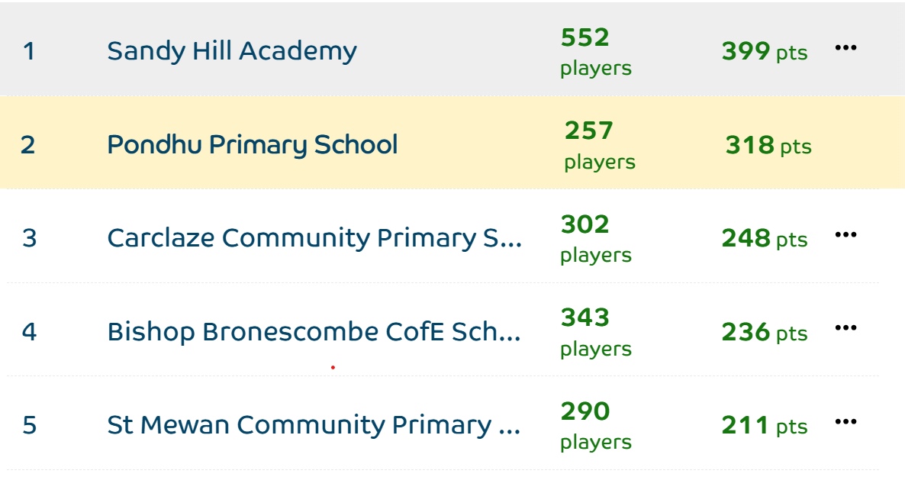

NURSERY SEPTEMBER 2026

If you have a child who is looking to start at our Pondhu Nursery in September 2026, please contact the school office to book their place.


CRICKET
On Monday, a group of Year 4 children took part in a cricket event at Poltair School. During the day, they developed key cricket skills, including fielding, batting, and bowling. Towards the end of the session, the children had the opportunity to apply what they had learned by playing matches against other schools. There were some great skills on display from everyone involved, and the group showed excellent teamwork and enthusiasm throughout the day.
SCHOOL GATES
For security reasons, parents are NOT to open any of the school gates.



Star Learners

The children have been fantastic this week and they have been chosen for a variety of reasons.
Reception – Finley for brilliant engagement in all lessons
Year 1 – Nancy for including some fantastic ideas in her writing
Year 2 – Alaynah for being very focussed and super engaged in all of her learning tasks this week
Year 3 – Molly for having such a positive week and working really hard
Year 4 – Daivik for working so hard in RWI and moving up a group
Year 5 – AB for the enthusiasm and engagement he brings to every lesson
Year 6 – Charlie for consistent hard work, effort and focus

Well done everyone!
ATTENDANCE
EYFS/KS1 ARIAL


WINNER - Jemison

Attendance this week
Montessori (R/Y1) – 92%
Jemison (Y1/2) – 98.3%
Attenborough (Y3) – 96.4%
Franklin (Y4) – 96.9%
Shackleton (Y5) – 99%
QEII (Y6) – 93.6%
Whole School – 95.5 %
KS2 ALFIE

WINNER - Shackleton

YEAR 6 SATS
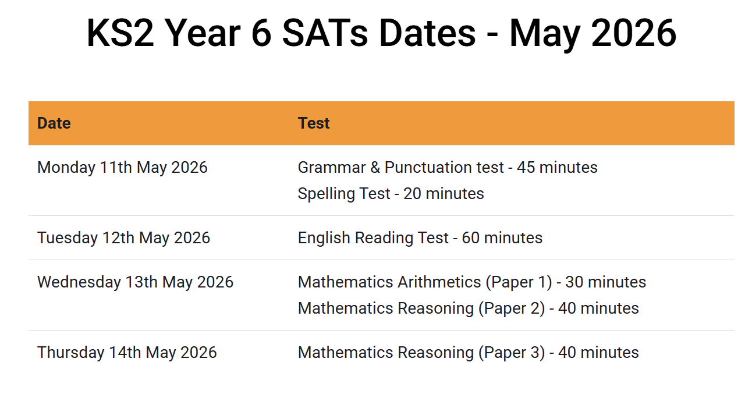
If your child is ill on one of the dates of the tests, please contact the school office as soon as possible on the morning of the test.

BRITISH VALUES CHAMPIONS
Reception / Year 1 – Melina for individual liberty for using her voice to answer questions
Year 1 / 2 – Lucas for showing kindness to his friends
Year 3 – Ethan F for being kind and respectful
Year 4 – Riley for being a respectful learner
Year 5 – Jensen for being such a kind and considerate walking and talking partner when we paired up with Reception and Year 1 for our ‘Beat the street’ walk.
Year 6 – Marley for his tolerance and respect on our Beat the Street walk



Well done to our British values champions!

SUMMER 1 TRIPS

Tuesday 5th May – Year 5 Tamar Bridge Learning Centre / Box museum Plymouth
Friday 15th May – Reception / Year 1 / Year 2 – Screech Owl Sanctuary
Wednesday 20th May – Year 6 National Marine Aquarium Plymouth
Friday 22nd May – Year 3 and Year 4 St.Michael’s Mount

SPORTS DAYS

This year we are going to hold a sports day for Reception and Key Stage 1 and a separate sports day for Key Stage 2.
These will be held on the following afternoons:
Reception and Key Stage 2 – Thursday 4th June
Key Stage 2 – Friday 12th June


Read Write Inc Virtual Classroom

Please find this week's Virtual Classroom video links in the document attached to this newsletter. These links enable children in Reception to Year 3 to practise their reading skills with you at home. They directly link to the skills they have been learning during their daily Read Write Inc sessions. You should be able to just click on the hyperlinks within the document and be taken straight to a video clip. Please set aside 10 minutes to watch films with your child each week, find a quiet space for your child to watch the film on a laptop, phone or tablet and praise your child as they join in with the lesson. Please see the diary dates for the upcoming parent information sessions where you can find out more information about Read Write Inc.
UPCOMING EVENTS

Tuesday 5th May – Year 5 Tamar Bridge STEM workshop
Monday 11th May – Thursday 14th May KS2 SATs week

Have a lovely bank holiday weekend.


Mrs Rachel Clift

