Year 6 House Captains
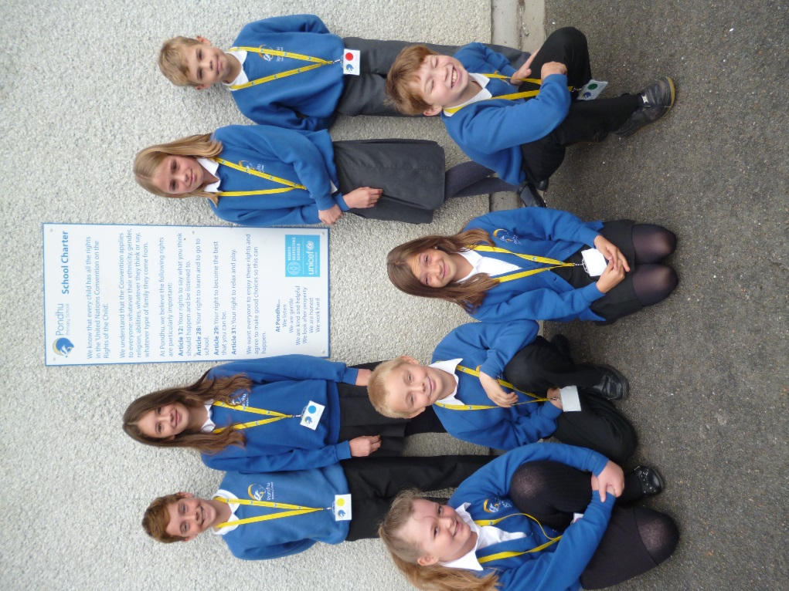
Cothele/Bill and Jak
Trerice/Harry and Niamh
Lanhydrock/Josh and Georgia
Trelissick /Abigail and Summer

