Charity
Our names are Oliver, Sophie, Kye, Dovile, Esra and Poppy.
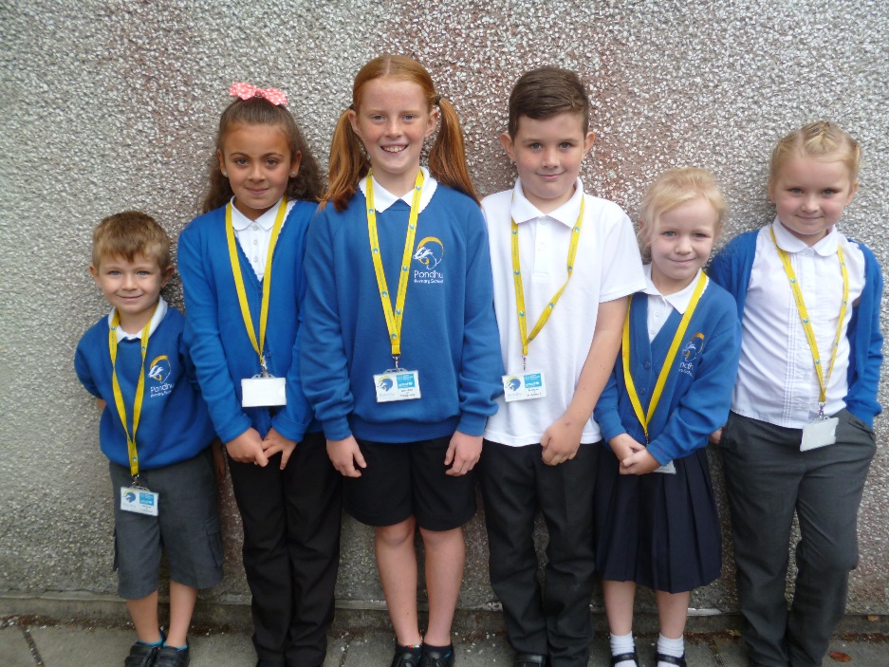
We organise fundraisers and help out on Summer and Christmas fairs. We get sent lots of requests from charities and decide which ones we can support. We make sure our community knows about what we are doing.

